All Languages have their Strengths and Weakness

**Machine Language in 1980’s**

Speaks directly to the CPU of a computer

Extremely difficult to write program

**Assembly Level Language in 1990’s**

Collections of Mnemonic Codes

Code: Add, sub, mul

**High Level Language** :: Similar to English Structure Language

**Ex::**

**C++ ::**  Microsoft Windows was mostly built using C++

**Objective C :**: Mac OSX and iOS were built with Objective-C

**Java ::** Created in **1995** by SUN Microsystems with intention of being run

on many different platforms

Ex: Android is built in Java

**PHP** : Created in 1995, over million websites are built using PHP

**Python ::** Created in **1989** for General Purpose language with intention of being **very readable**

Ex: **Youtube was built with python**

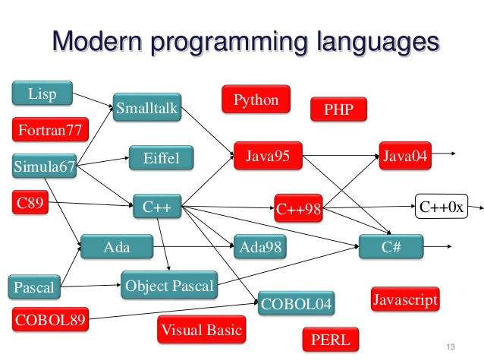

**Top Computer Languages**

<http://statisticstimes.com/tech/top-computer-languages.php>

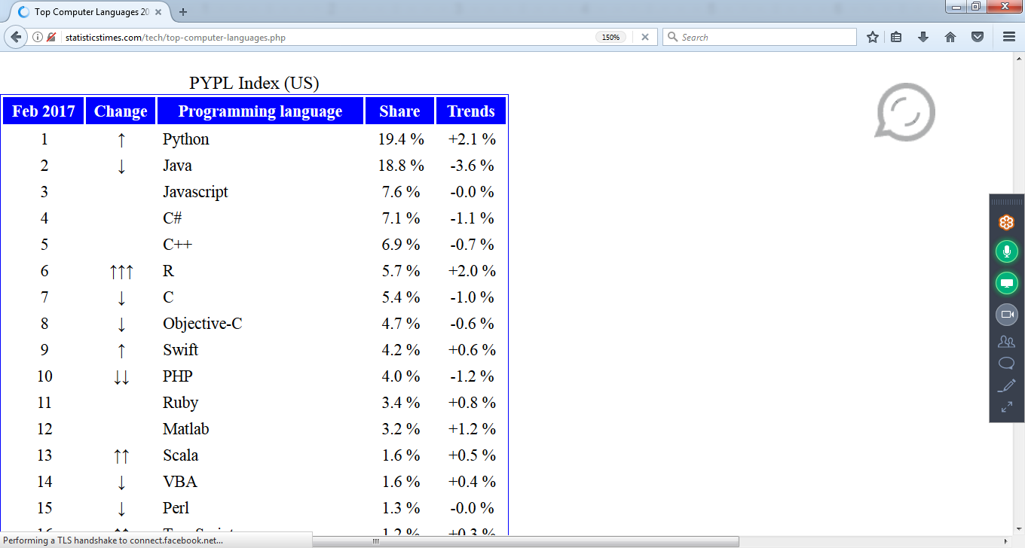

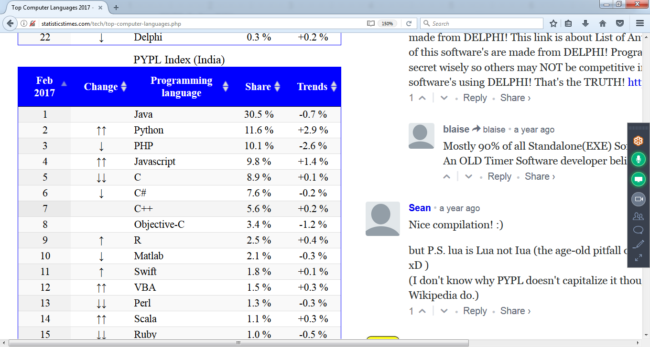

**Most Popular Languages**

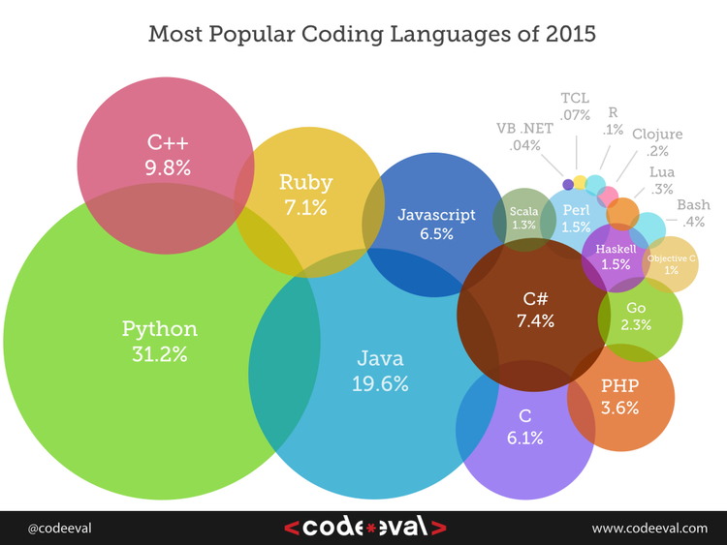

it is a widely used programming language.

* **Google** - Python is one of the key language used in google.
* **Philips** - Philips uses Python for the sequencing language ( language that tells what steps each **Robot** should take ).
* **Frequentis** - Frequentis is the originator of TAPTools, a software product that is used for **air traffic control** in many airports. This particular tool provides updates on the weather and runway conditions to air traffic controllers. So, you depend on Python when you fly.
* **Quora** - Quora also chose Python for its development
* **CodesDope** - Yes, we also use Python.
* **Battlefield 2** - Battlefield 2 uses Python to implement core elements of its gameplay such as score-keeping and team-balancing.
* **Instagram** - Instagram also uses Python for its backend
* **Walt Disney Feature Animation** - Walt Disney Feature Animation is also using Python to make their animation production system more efficient in scripting.
* **NASA** - Johnson Space center uses Python in its Integrated Planning System as the standard scripting language.
* **YouTube** - **We all love youtube and and youtube loves using Python**
* **DropBox** - Dropbox allows us to store, sync, and share almost anything using the power of Python.
* **Pinterest** - Pinterest is a visual discovery tool that allows users to showcase their interests through the posting of pictures.

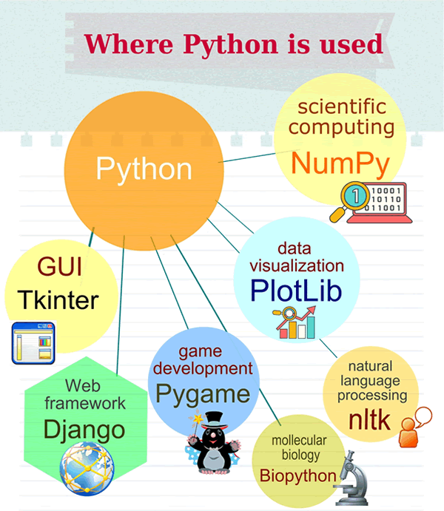

**List of Libraries**

|  |  |  |  |
| --- | --- | --- | --- |
| Graphical interface | wxPython | [http://wxpython.org](http://wxpython.org/) |  |
| Graphical interface | pyGtk | [http://www.pygtk.org](http://www.pygtk.org/) |  |
| Graphical interface | pyQT | <http://www.riverbankcomputing.co.uk/pyqt/> |  |
| Graphical interface | Pmw | <http://pmw.sourceforge.net/> |  |
| Graphical interface | Tkinter 3000 | <http://effbot.org/zone/wck.htm> |  |
| Graphical interface | Tix | <http://tix.sourceforge.net/> |  |
|  |  |  |  |
| Database | MySQLdb | <http://sourceforge.net/projects/mysql-python> |  |
| Database | PyGreSQL | <http://www.pygresql.org/> |  |
| Database | Gadfly | <http://gadfly.sourceforge.net/> |  |
| Database | SQLAlchemy | <http://www.sqlalchemy.org/> |  |
| Database | psycopg | <http://www.initd.org/pub/software/psycopg/> |  |
| Database | kinterbasdb | <http://kinterbasdb.sourceforge.net/> |  |
| Database | cx_Oracle | <http://www.cxtools.net/default.aspx?nav=downloads> |  |
| Database | pySQLite | <http://initd.org/tracker/pysqlite> |  |
|  |  |  |  |
| MSN Messenger | msnlib | <http://auriga.wearlab.de/~alb/msnlib/> |  |
| MSN Messenger | pymsn | <http://telepathy.freedesktop.org/wiki/Pymsn> |  |
| MSN Messenger | msnp | <http://msnp.sourceforge.net/> |  |
| Network | Twisted | <http://twistedmatrix.com/> |  |
| Images | PIL | <http://www.pythonware.com/products/pil/> |  |
| Images | gdmodule | <http://newcenturycomputers.net/projects/gdmodule.html> |  |
| Images | VideoCapture | <http://videocapture.sourceforge.net/> |  |
|  |  |  |  |
| Sciences and Maths | scipy | <http://www.scipy.org/> |  |
| Sciences and Maths | NumPy | <http://numpy.scipy.org//> |  |
| Sciences and Maths | numarray | <http://www.stsci.edu/resources/software_hardware/numarray> |  |
| Sciences and Maths | matplotlib | <http://matplotlib.sourceforge.net/> |  |
|  |  |  |  |
| Games | Pygame | <http://www.pygame.org/news.html> |  |
| Games | Pyglet | <http://www.pyglet.org/> |  |
| Games | PySoy | <http://www.pysoy.org/> |  |
| Games | pyOpenGL | <http://pyopengl.sourceforge.net/> |  |
|  |  |  |  |
| Jabber | jabberpy | <http://jabberpy.sourceforge.net/> |  |
|  |  |  |  |
| Web | scrape | <http://zesty.ca/python/scrape.html> |  |
| Web | Beautiful Soup | <http://crummy.com/software/BeautifulSoup> |  |
| Web | pythonweb | <http://www.pythonweb.org/> |  |
| Web | mechanize | <http://wwwsearch.sourceforge.net/mechanize/> |  |
|  |  |  |  |
| Localisation | geoname.py | <http://www.zindep.com/blog-zindep/Geoname-python/> |  |
|  |  |  |  |
| Serial port | pySerial | <http://pyserial.sourceforge.net/> |  |
| Serial port | USPP | <http://ibarona.googlepages.com/uspp> |  |
|  |  |  |  |
| Parallel Port | pyParallel | <http://pyserial.sourceforge.net/pyparallel.html> |  |
|  |  |  |  |
| USB Port | pyUSB | <http://bleyer.org/pyusb/> |  |
|  |  |  |  |
| Windows | ctypes | <http://starship.python.net/crew/theller/ctypes/> |  |
| Windows | pywin32 | <http://sourceforge.net/projects/pywin32/> |  |
| Windows | pywinauto | <http://www.openqa.org/pywinauto/> |  |
| Windows | pyrtf | <http://pyrtf.sourceforge.net/> |  |
| Windows | wmi | <http://timgolden.me.uk/python/wmi.html> |  |
|  |  |  |  |
| PDA/GSM/Mobiles | pymo | <http://www.awaretek.com/pymo.html> |  |
| PDA/GSM/Mobiles | pyS60 | <http://sourceforge.net/projects/pys60> |  |
|  |  |  |  |
| Sound | pySoundic | <http://pysonic.sourceforge.net/> |  |
| Sound | pyMedia | <http://pymedia.org/> |  |
| Sound | FMOD | <http://www.fmod.org/> |  |
| Sound | pyMIDI | <http://www.cs.unc.edu/Research/assist/developer.shtml> |  |
|  |  |  |  |
| GMail | libgmail | <http://libgmail.sourceforge.net/> |  |
| Google | pyGoogle | <http://pygoogle.sourceforge.net/> |  |
| Expect | pyExpect | <http://pexpect.sourceforge.net/> |  |
| WordNet | pyWordNet | <http://osteele.com/projects/pywordnet/> |  |
| Command line | cmd | <http://blog.doughellmann.com/2008/05/pymotw-cmd.html> |  |
| Compiler backend | llvm-py | <http://mdevan.nfshost.com/llvm-py/> |  |
| 3D | VPython | [http://vpython.org](http://vpython.org/) |  |

**1985 (Python), 1995 (Java)**

**Why we need to step in PYTHON**

1. **Free and Open Source ( More Libraries)**
2. **Easy to Learn :: Less 75% code**
3. **OOP language : Reusability**
4. **Powerful and Robust : High Traffics sites**
5. **Flexible**

**Scripting Language : Files, OS, Strings**

**PYTHON : 30 Hours : 10 to 11 am :: Rs 3,000**

Web Applications : **Django** Framework ( 3 to 4 lacs)

AWS and Devops : **Boto (5 to 7 lac)**

Data Science : **Numpy, Scipy, plotlib, pandas ( 7 to 10 lacs)**

**RPA : Blueprism, openspan**

Big Data : Hadoop

Networking, Security

Tableau, Testing Tools : **Selenium**

Ethical Hacking, Networking

**Python.org**

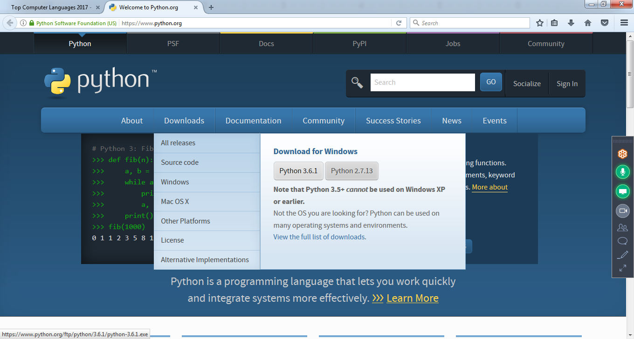

# 

# 

# **Java vs. Python**

# **Statically Typed**

# In Java, all variable names (along with their types) must be explicitly declared

# **Dynamically Typed**

In Python, you **never declare** anything. An assignment statement binds a name to an object

>>> a =2 4

>>> f = 4.5

>>> print(a,f)

24 4.5

>>> st = 'python program '

>>> st

'python program '

>>>

2) The data declaration which is necessary in Java but not in Python

|  |  |  |
| --- | --- | --- |
| public class HelloWorld {  public static void main (String[] args)  {  System.out.println("Hello, world!");  } } | | print "Hello, world!"  print("Hello, world!") # Python version 3 |

|  |  |  |
| --- | --- | --- |
| int myCounter = 0; String myString = **String.valueOf**(myCounter); if (myString.equals("0")) ... | | myCounter = 0 myString = **str**(myCounter) if myString == "0": ... |
| // print the integers from 1 to 9 for (int i = 1; i < 10; i++) {  System.out.println(i); } | | // print the integers from 1 to 9 for i in **range(1,10)** :  print i |

>>> n = int(input('Enter value for n '))

Enter value for n 6

>>> for i in range(**n**):

print(i)

0

1

2

3

4

5

>>> n = 17

>>> for i in range(1,11,2):

print(n, ' * ', i, ' = ', n*i)

17 * 1 = 17

17 * 3 = 51

17 * 5 = 85

17 * 7 = 119

17 * 9 = 153

>>>

>>> n = int(input('Enter value for n '))

Enter value for n 19

>>> for i in range(1,10):

print(n, ' * ', i, ' = ', n*i)

19 * 1 = 19

19 * 2 = 38

19 * 3 = 57

19 * 4 = 76

19 * 5 = 95

19 * 6 = 114

19 * 7 = 133

19 * 8 = 152

19 * 9 = 171

>>>

3)

>>> a = 24

>>> a

24

>>> type(a)

<class 'int'>

>>>

Accept number and print Table using functions

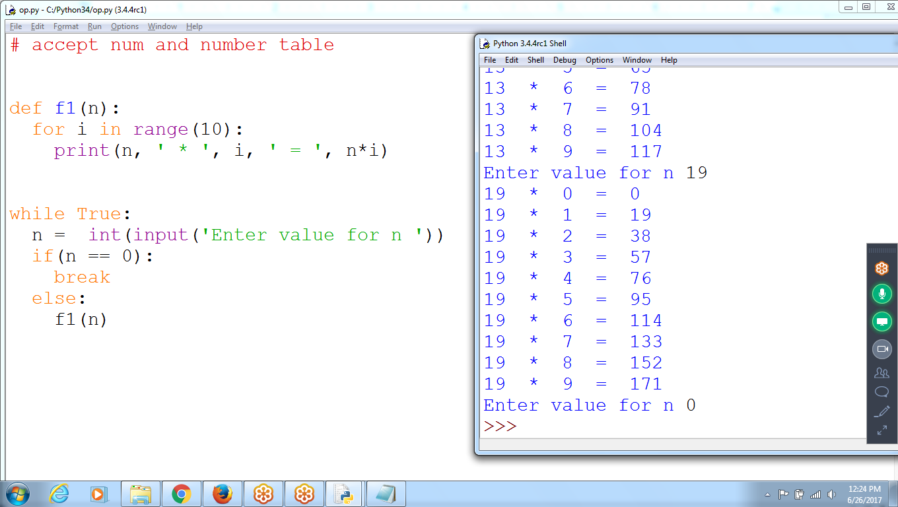

# accept num and number table

def f1(n):

for i in range(10):

print(n, ' * ', i, ' = ', n*i)

while True:

n = int(input('Enter value for n '))

if(n == 0):

break

else:

f1(n)

# print given table number using functions

# 2 * 1 = 2

# 2 * 2 = 4

def f1(n):

for i in range(1,11):

print(n, ' * ', i, ' = ', n*i)

n = int(input('enter value for n'))

f1(n)

If you are programming in Java, need to write three constructors, with three different signatures.

If you are programming in Python, write only a single constructor, with default values for the optional arguments.

|  |  |  |
| --- | --- | --- |
| public class Employee {  private String myEmployeeName;  private int myTaxDeductions = 1;  private String myMaritalStatus = "single";   //--------- constructor #1 -------------  public Employee(String EmployeName)  {  this(employeeName, 1);  }   //--------- constructor #2 -------------  public Employee(String EmployeName, int taxDeductions)  {  this(employeeName, taxDeductions, "single");  }   //--------- constructor #3 -------------  public Employee(String EmployeName,  int taxDeductions,  String maritalStatus)  {  this.employeeName = employeeName;  this.taxDeductions = taxDeductions;  this.maritalStatus = maritalStatus;  } ... | | class Employee():   def **__init__**(self,  employeeName  , taxDeductions=1  , maritalStatus="single"  ):   self.employeeName = employeeName  self.taxDeductions = taxDeductions  self.maritalStatus = maritalStatus ...  In Python, a class has only one constructor.  The constructor method is simply another method of the class, but one that has a special name: **__init__** |

4) python is Scripting Language

More functionality with strings, Files and OS Operations

It is dynamic language ( no need declaration)

Java’s string-handling capabilities are surprisingly weak.

|  |  |  |  |
| --- | --- | --- | --- |
| **Function or Method** | **Java** | | **Python** |
| Remove leading and trailing whitespace from string **s** | s.trim() | | s.strip() |
| Remove **leading whitespace** from string **s** | (not available) | | s.lstrip() |
| Remove **trailing whitespace** from string **s** | (not available) | | s.rstrip() |

name = input('Enter name: ')

Enter name: **prem prakash karthik**

>>> name.**split()**

**['prem', 'prakash', 'karthik']**

>>>

>>> 'ppython prog ptyh'.split()

['ppython', 'prog', 'ptyh']

>>> 'ppython prog ptyh'.split('p')

['', '', 'ython ', 'rog ', 'tyh']

>>>

>>> ' python program langa '.strip()

'python program langa'

5)

The Java code on the left has 5 control characters: **( ) { } ;**

Python code has only one control character, the colon

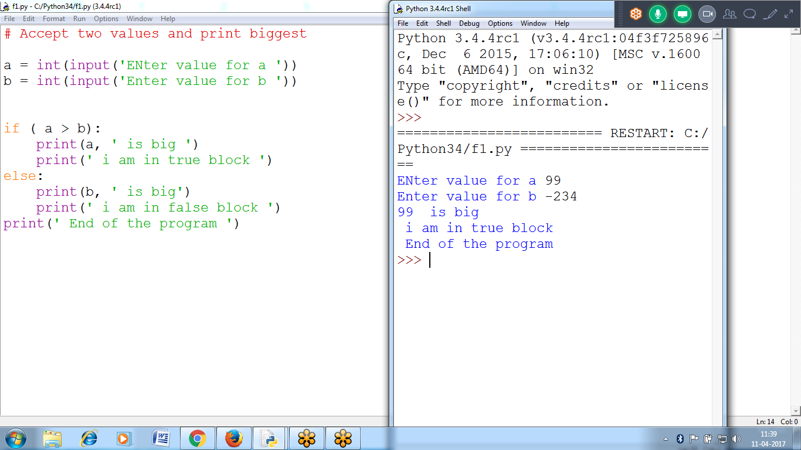

# Accept two values and print biggest

a = int(input('ENter value for a '))

b = int(input('Enter value for b '))

if ( a > b):

print(a, ' is big ')

print(' i am in true block ')

else:

print(b, ' is big')

print(' i am in false block ')

print(' End of the program ')

6)

Java requires a substantial amount of setup

Python requires NO setup, Python will help you learn programming faster

**7)**

Python:

addresses = getAddresses()

Java:

List<AddressObject> addresses = getAddresses();

* + Python was shorter to write, addresses?
  + Java is clear as can be about what *everything* what Is it an object? An Array? A comma-separated string?

**8) Python Vs Java Compilers**

**Python is an intepeter**

**For Java Libraries, developers can use Jython**

**For .net, developers can use IronPython**

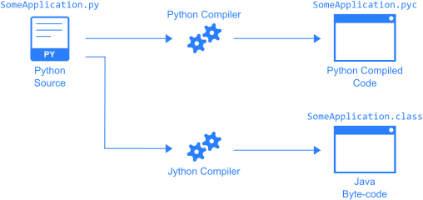

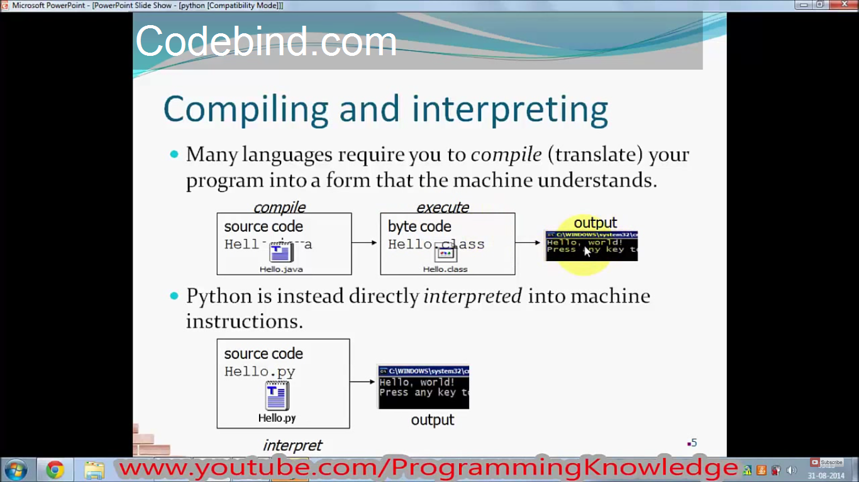

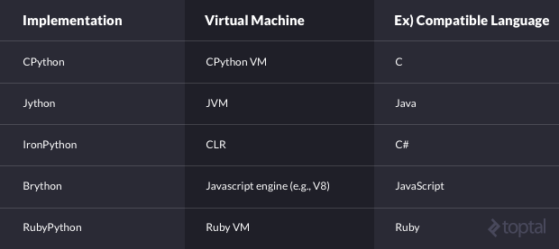

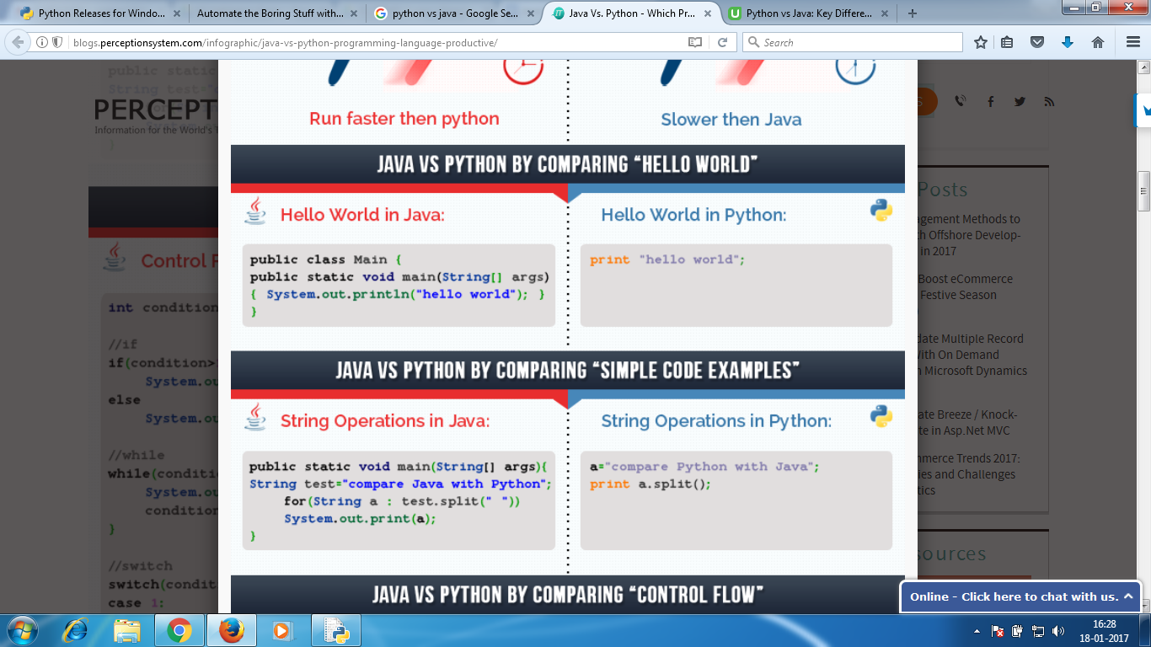

**a = int(input('enter value for a '))**

**b = int(input('enter value for a '))**

**print(' Values between range ', a, b)**

**for i in range(a,b):**

**print(i)**

**>>> str = 'python progarming'**

**>>> str.split()**

**['python', 'progarming']**

**>>> str.split('p')**

**['', 'ython ', 'rogarming']**

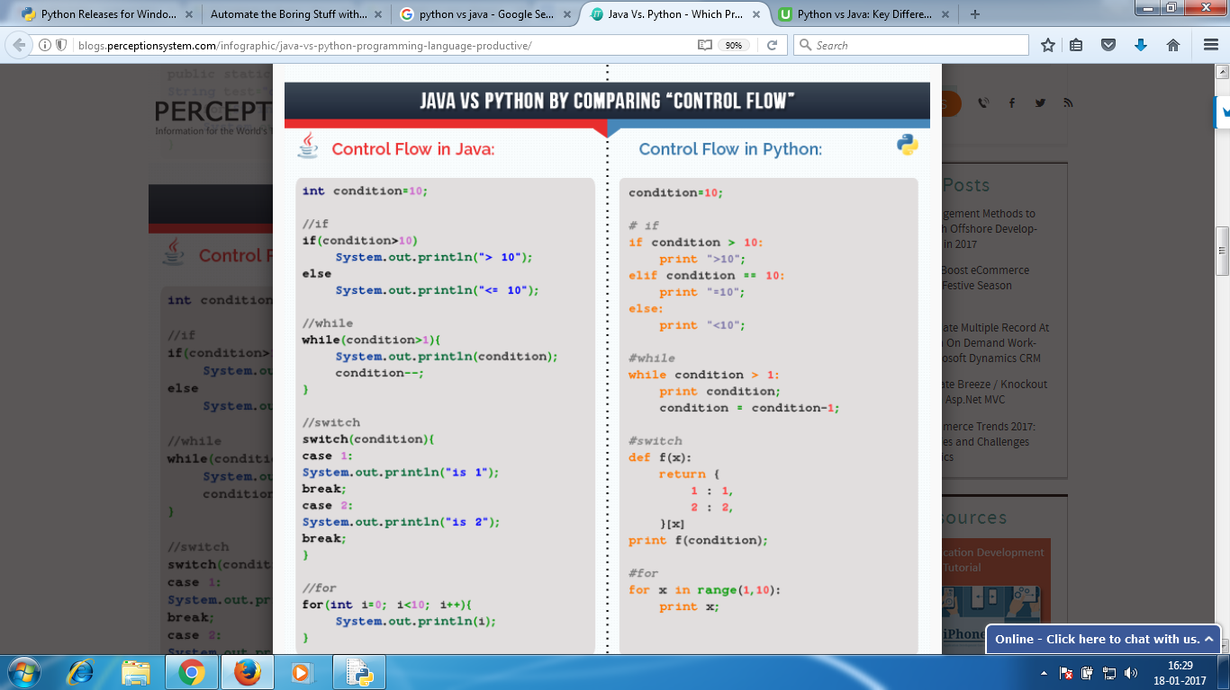

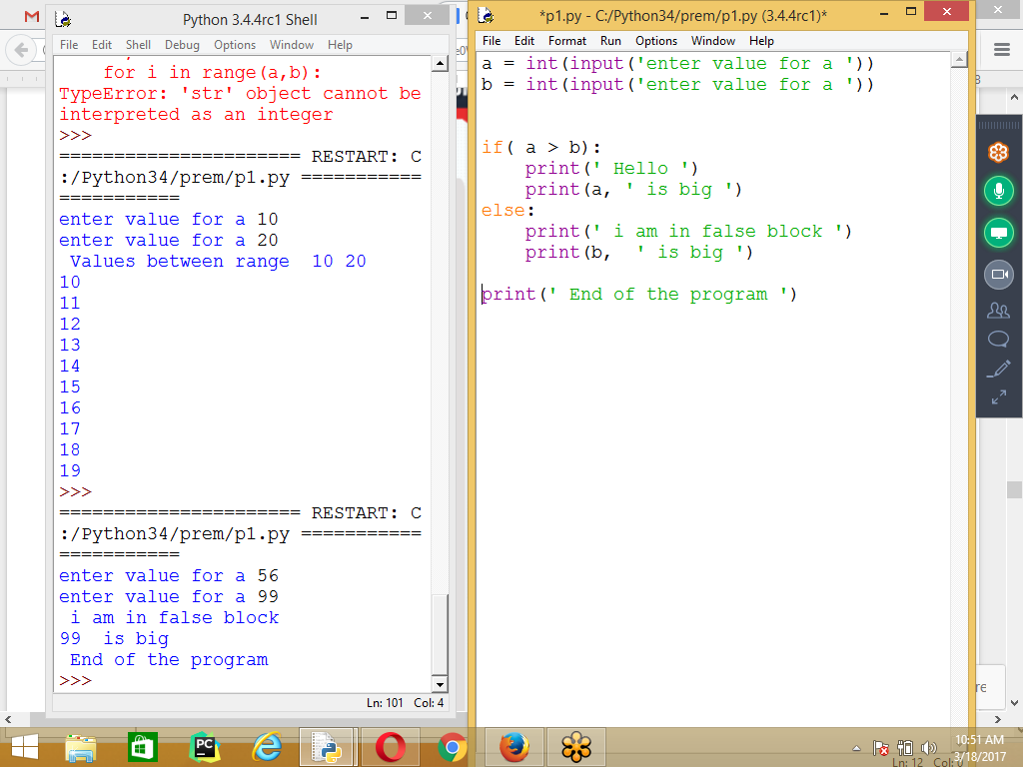

**a = int(input('enter value for a '))**

**b = int(input('enter value for a '))**

**if( a > b):**

**print(' Hello ')**

**print(a, ' is big ')**

**else:**

**print(' i am in false block ')**

**print(b, ' is big ')**

**print(' End of the program ')**

**for i in range(1,11):**

**print(n, ' * ', i, ' = ' , n * i)**

**19 * 1 = 19**

**19 * 2 = 38**

**19 * 3 = 57**

**19 * 4 = 76**

**19 * 5 = 95**

**19 * 6 = 114**

**19 * 7 = 133**

**19 * 8 = 152**

**19 * 9 = 171**

**19 * 10 = 190**

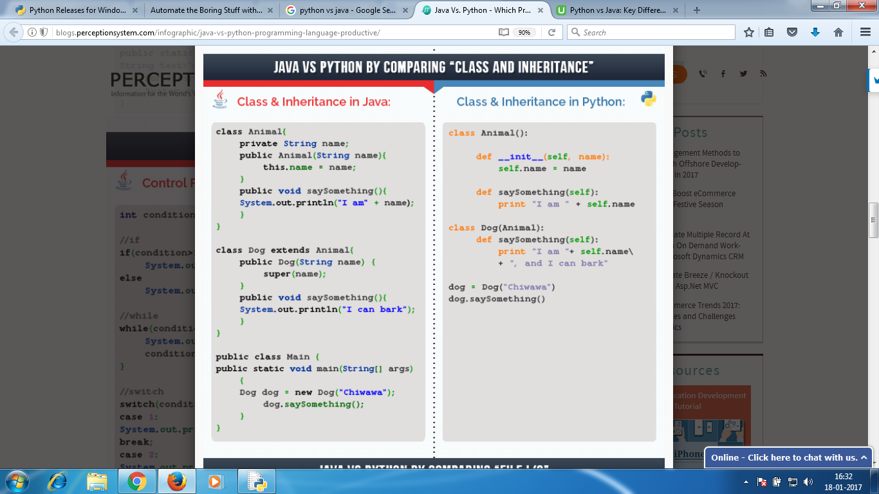

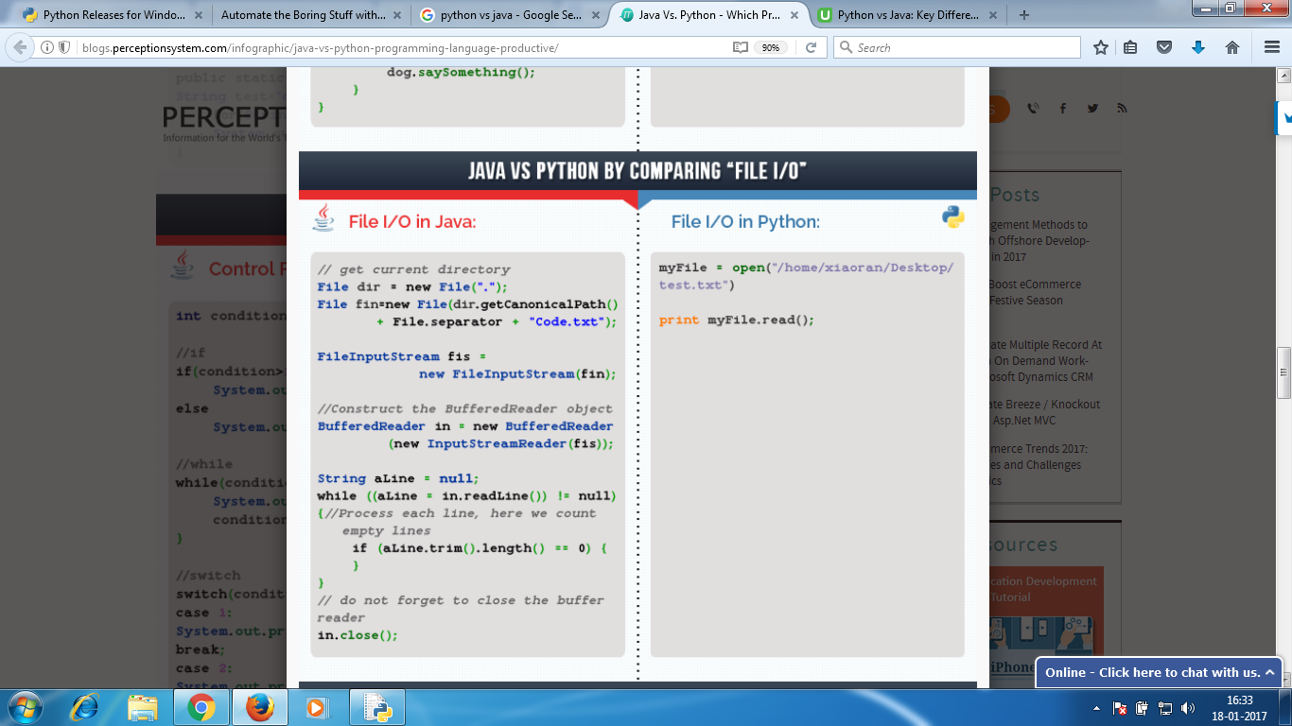

**Reading Data from a txt file**

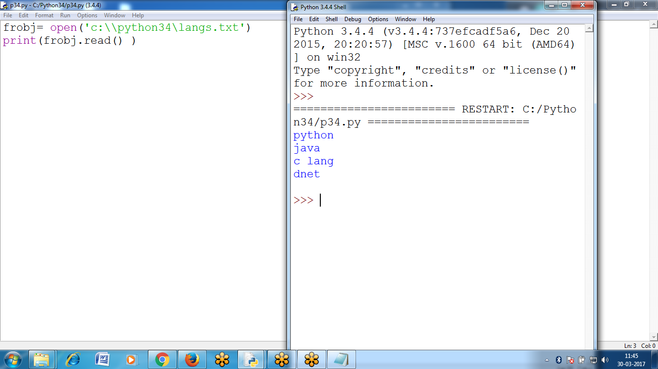

**frobj= open('c:\\python34\langs.txt')**

**print(frobj.read() )**

**>>> fo = open('c:\\python34\\namest.txt')**

**>>> for f in fo:**

**print(f)**

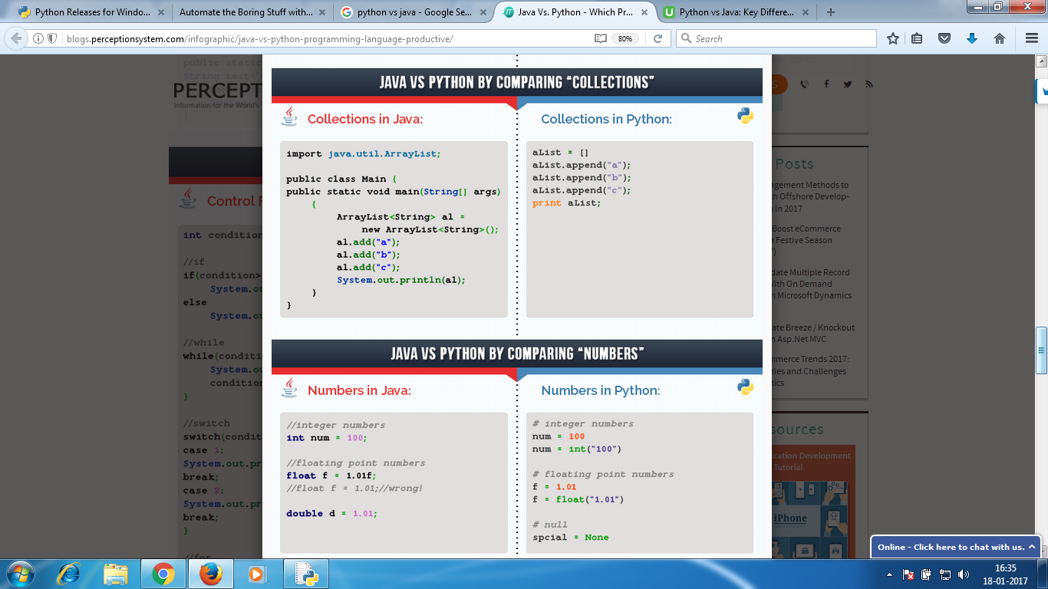

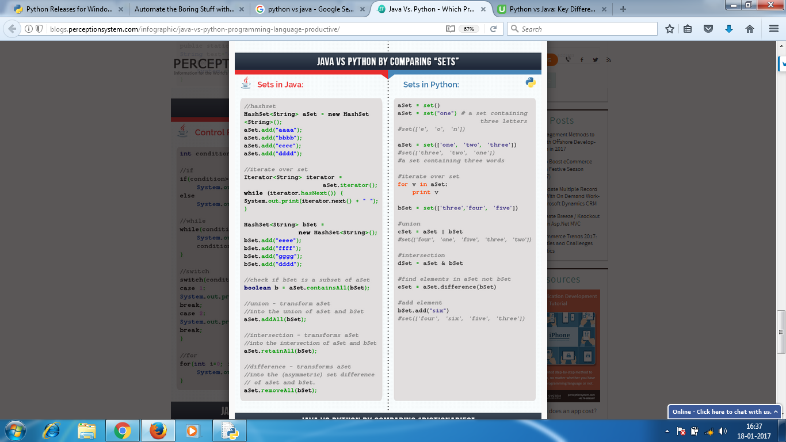

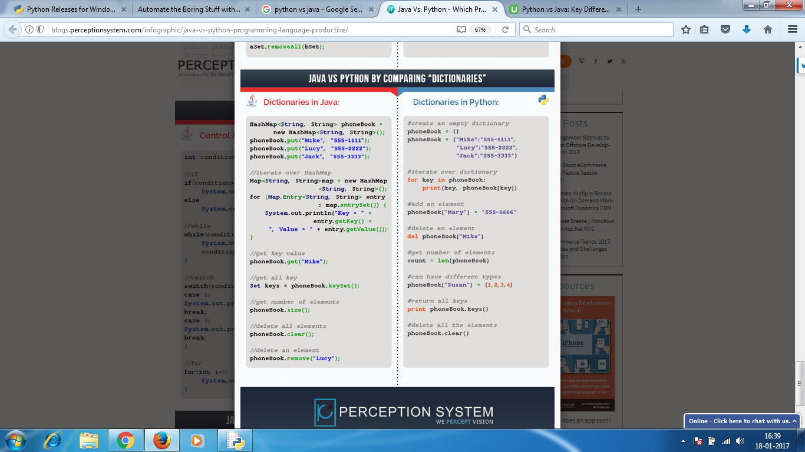

**Speed vs Portability**

Java ::

* The advantage of Java is that it can be used to create platform-independent applications.
* The disadvantage of running inside a virtual machine is that Java programs run more slowly than Python programs

Python ::

**To RUN Python programs you need Interpreter** that can turn Python code, that particular operating system can understand.

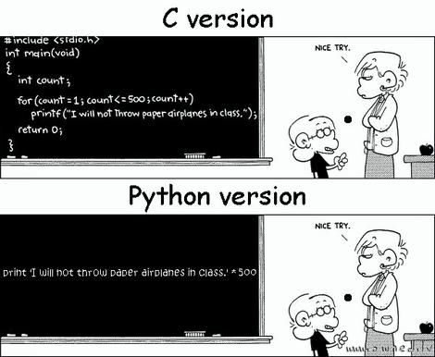

**>>> res = 9 ** 9999**

**>>> sres = str(res)**

**>>> len(sres)**

**9542**

**>>>**

>>> 72 ** 10

3743906242624487424

>>> 72 ** 99

7514795154970345655708904256957660372905528939591738550433777768216607189264440982300747701618490183233144172562546469651649796084881469155351533306963405271273063147084013054520721408

>>> 'hello'*10

'hellohellohellohellohellohellohellohellohellohello'

>>>

9) All Languages Comparisons from PYTHON

https://www.python.org/doc/essays/comparisons/

[Programming Languages Comparison](https://www.google.co.in/url?sa=i&rct=j&q=&esrc=s&source=images&cd=&ved=0ahUKEwjG9vKAkLfRAhXJQ48KHUYxCOkQjhwIBQ&url=https%3A%2F%2Fwowjava.wordpress.com%2F2009%2F01%2F15%2Fprogramming-languages-comparison%2F&psig=AFQjCNH4J685kjYLIwfE82OQBU55Ga0iug&ust=1484122127324678)

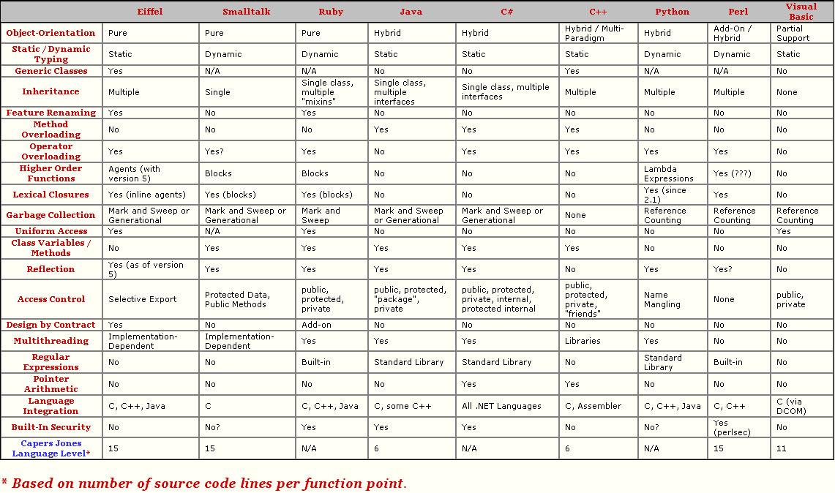

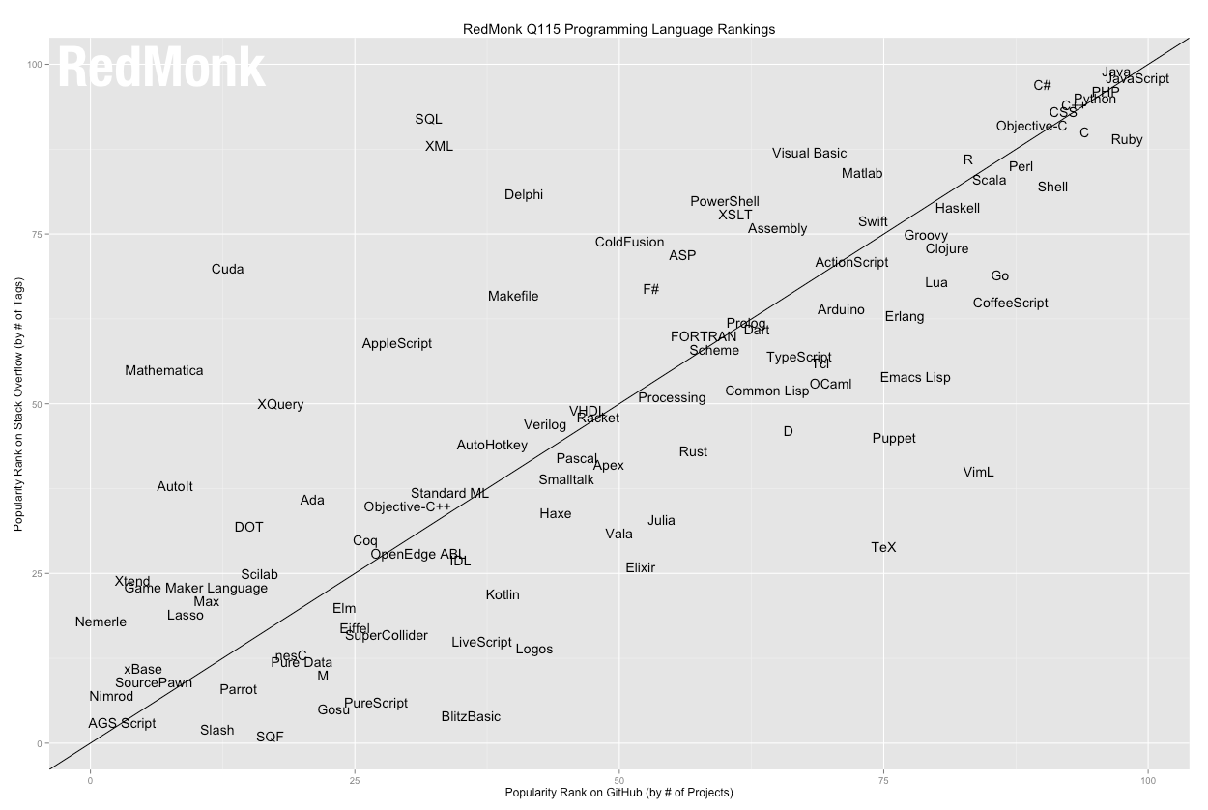

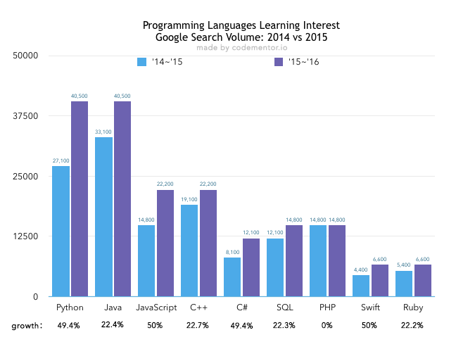

**Most Popular Languages**



**Python examples**

**To find given string contains Phone number in Regular Expression Format**

**import re**

**st = input('enter Any string ')**

**reobj= re.compile('\d\d\d-\d\d\d-\d\d\d\d')**

**print(reobj.search(st))**

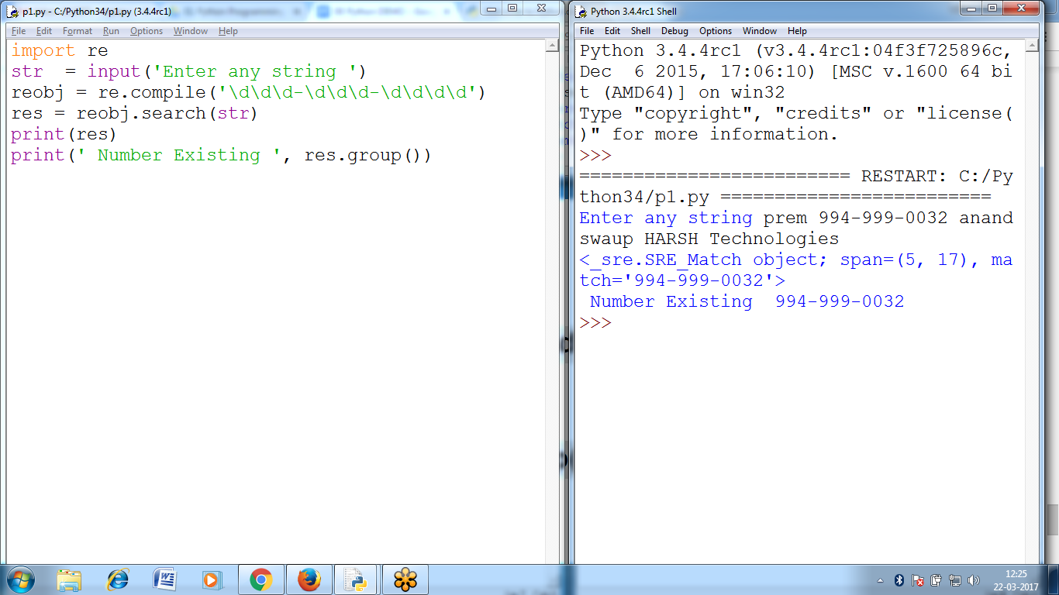

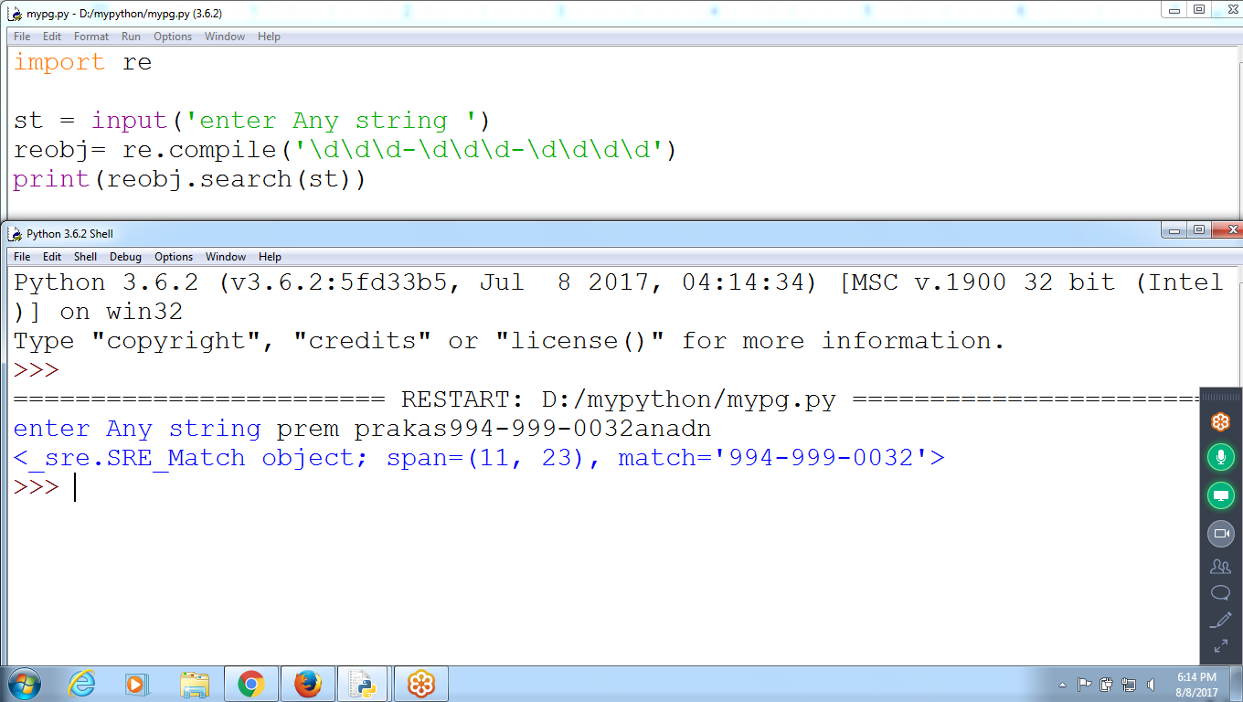

**# 1 Program to find number of each character occurrence in a given string**

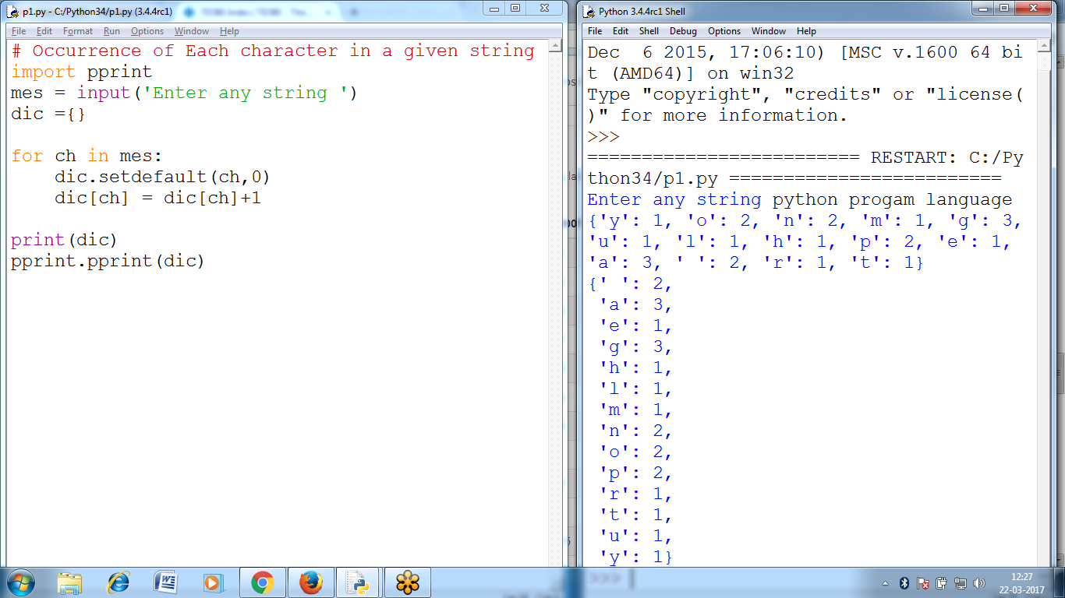

**#2 Occurrence of Each character in a given string**

**import pprint**

**mes = input('Enter any string ')**

**dic ={}**

**for ch in mes:**

**dic.setdefault(ch,0)**

**dic[ch] = dic[ch]+1**

**print(dic)**

**pprint.pprint(dic)**

**# Prog 3 Two Dimensional List**

ls = [

['ramu','cloud',1],

['siva','erp',2],

['raju','bigdata',3] ]

uid = input('Enter Username ')

pwd = input('Enter password ')

eid = int(input('Enter Employee id '))

**if [uid,pwd,eid] in ls:**

print('Grant Access to ', uid)

else:

print('can NOT Access ')

**Interchange of 4 values**

**>>> a=10**

**>>> b=20**

**>>> c=30**

**>>> d=40**

**>>> print(a,b,c,d)**

**10 20 30 40**

**>>> a,b,c,d = d,c,b,a # Interchange values**

**>>> print(a,b,c,d)**

**40 30 20 10**

**>>>**

**Multiple Return values**

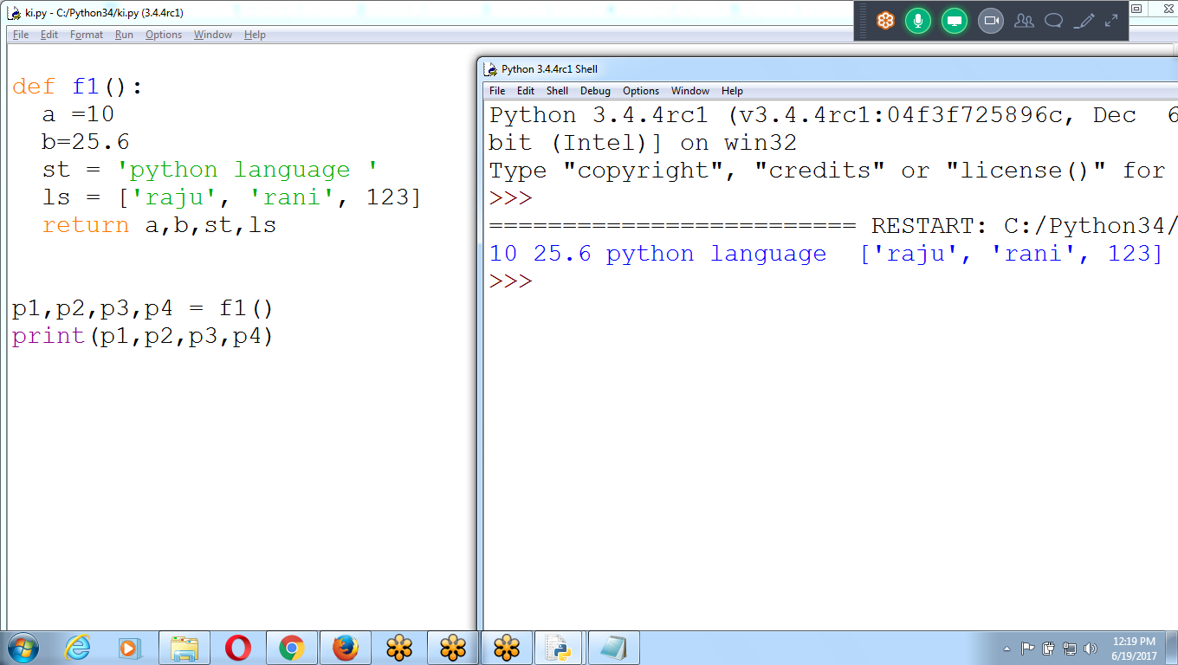

def f1():

a =10

b=25.6

st = 'python language '

ls = ['raju', 'rani', 123]

return a,b,st,ls

p1,p2,p3,p4 = f1()

print(p1,p2,p3,p4)

>>> os.path.**getsize('d:\\myfold\\names.txt') # File Size**

40

>>>

**>>> import shutil, os**

>>> **shutil.copytree(**'d:\\myfold', 'd:\\bacmyfol')

'd:\\bacmyfol'

>>> os.listdir('D:\\')

**>>> os.listdir('d:\\bacmyfol')**

['addr.txt', 'bacnames.txt', 'body.txt', 'example.txt', 'example2.txt', 'hello.txt', 'hellop.txt', 'hellot.txt', 'mynam9.docx', 'mynamesbody.txt', 'nambod.txt', 'nambod1.txt', 'namebody.txt', 'names.txt', 'namesbody.txt']

>>>

>>> shutil.rmtree('d:\\bacmyfol') **# Removes subfolder files**

>>>

**# Find list of Filenames and Folders**

import os

for fold, sfs, fns in os.walk('**d:\\’**):

print(' Current Folder name ' + fold)

for sf in sfs:

print(sf)

for fn in fns:

print(fn)

x = input()

Success:

Easy to Learn

OOPs : Reusability

Number of Libraries (Games, Scientific, Maths)

It is General Purposed Programing Language **Career Perspective**

**Python Training :: Rs: 3,000**

**Duration : 30 Hours (10 to 11 am)**

**In Trainings :: Step by Step Notes with Screenshots**

Classroom : any number of Batches can Attend & Revise

**Recording class for Revision**

**Details : Madhavi 9885 6262 89**

[**https://global.gotomeeting.com/join/396530733**](https://global.gotomeeting.com/join/396530733)

**Can Attend Online or ClassRoom**

**Scripting** Uses **PYTHON ( Strings, OS, Files)**

**Web Technology django** uses **PYTHON (Java, .net, php)**

**Data Science** Analytics uses **PYTHON ®**

**Machine Learning, Deep Learning**

**Natural Language Prog,**

**Sentiment Analysis, Linear Regression**

Amazon **Web Services** uses **PYTHON (Python)**

**Mobile Technology FLASK**

**Big Data** **Hadoop** uses **PYTHON ( Java)**

**Automation Tools** **Devops** uses **PYTHON**

**Reporting Tableau and Testing Tools selenium**

GUI, Gamings

**Declare variable, if-else, loop, function**

**String, functions, collection**

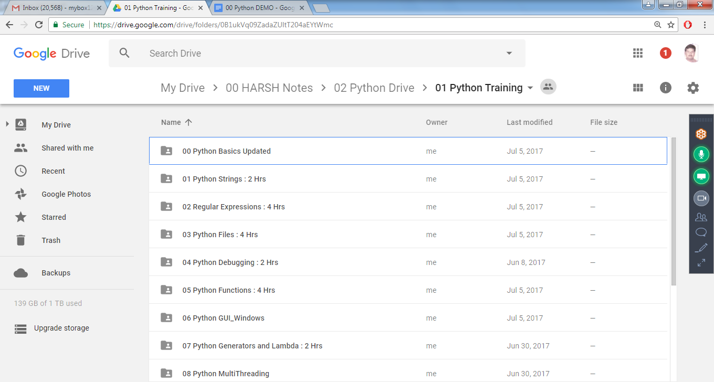

As mentioned above, it is a widely used programming language. Some of the places where Python is used are :

* **Google** - Python is one of the key language used in google.
* **Philips** - Philips uses Python for the sequencing language ( language that tells what steps each robot should take ).
* **Frequentis** - Frequentis is the originator of TAPTools, a software product that is used for air traffic control in many airports. This particular tool provides updates on the weather and runway conditions to air traffic controllers. So, you depend on Python when you fly.
* **Quora** - Quora also chose Python for its development
* **CodesDope** - Yes, we also use Python.
* **Battlefield 2** - Battlefield 2 uses Python to implement core elements of its gameplay such as score-keeping and team-balancing.
* **Instagram** - Instagram also uses Python for its backend
* **Walt Disney Feature Animation** - Walt Disney Feature Animation is also using Python to make their animation production system more efficient in scripting.
* **NASA** - Johnson Space center uses Python in its Integrated Planning System as the standard scripting language.
* **Civilization 4** - The new addition to the legendary strategy game series has all of its inner logic, including AI, implemented in Python.
* **YouTube** - We all love youtube and and youtube loves using Python
* **DropBox** - Dropbox allows us to store, sync, and share almost anything using the power of Python.
* **Pinterest** - Pinterest is a visual discovery tool that allows users to showcase their interests through the posting of pictures.

**https://www.python.org**

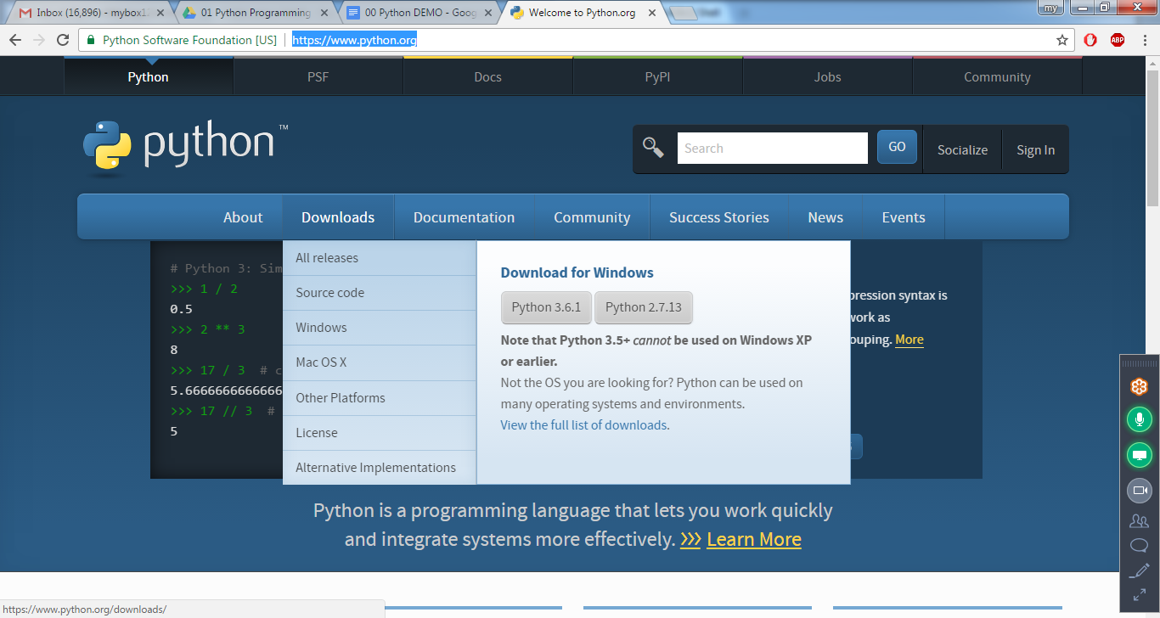

Python Basics Examples

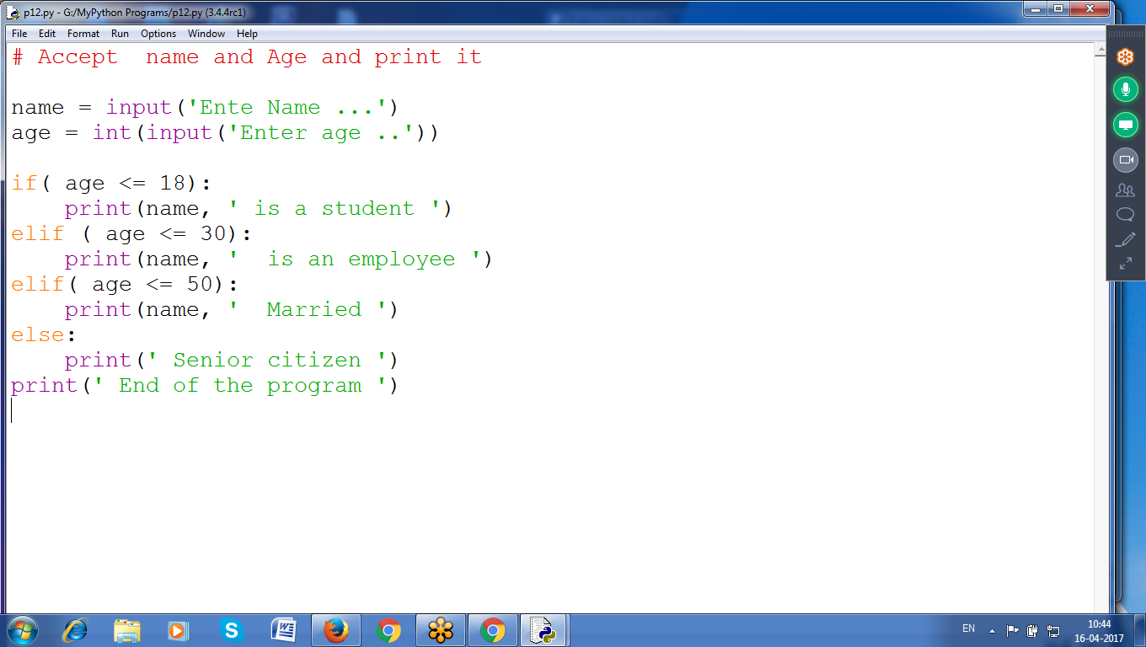

Using Nested If

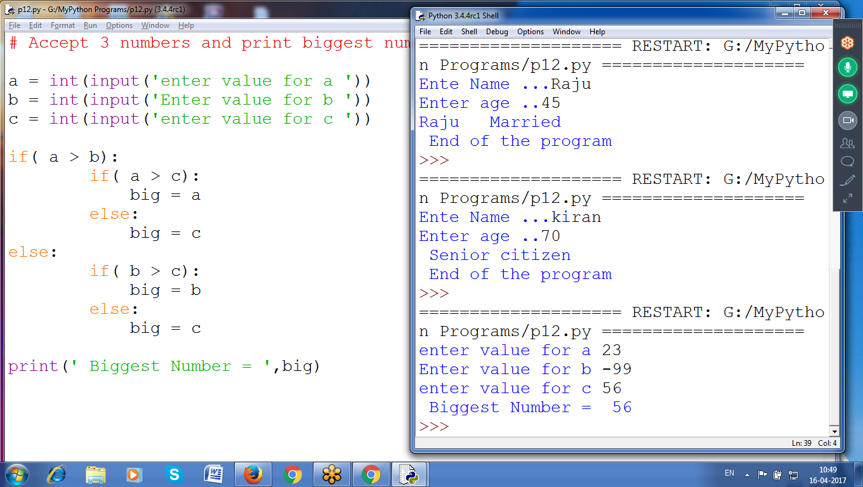

# Accept 3 numbers and print biggest number

a = int(input('enter value for a '))

b = int(input('Enter value for b '))

c = int(input('enter value for c '))

if( a > b):

if( a > c):

big = a

else:

big = c

else:

if( b > c):

big = b

else:

big = c

print(' Biggest Number = ',big)

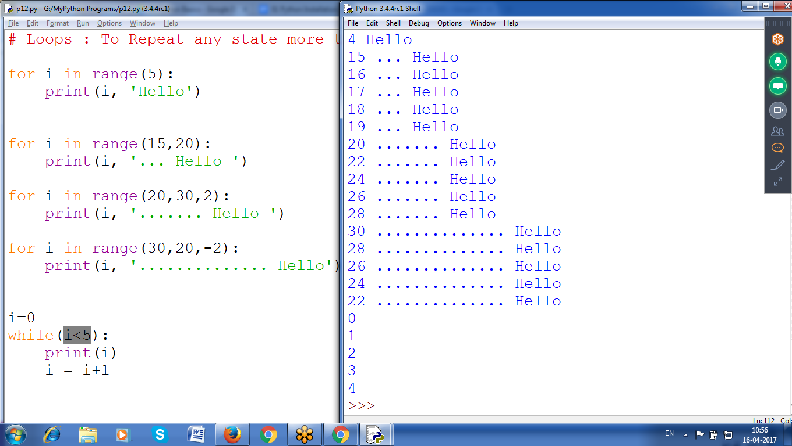

# Loops : To Repeat any state more than

for i in range(5):

print(i, 'Hello')

for i in range(15,20):

print(i, '... Hello ')

for i in range(20,30,2):

print(i, '....... Hello ')

for i in range(30,20,-2):

print(i, '.............. Hello')

i=0

while(i<5):

print(i)

i = i+1

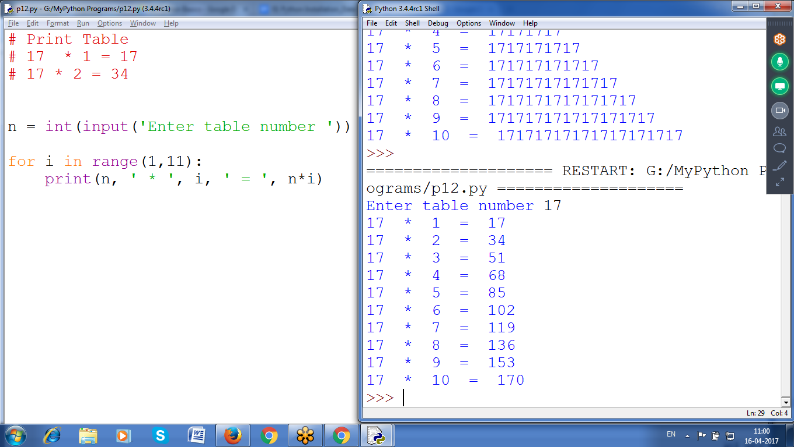

# Print Table

# 17 * 1 = 17

# 17 * 2 = 34

n = int(input('Enter table number '))

for i in range(1,11):

print(n, ' * ', i, ' = ', n*i)

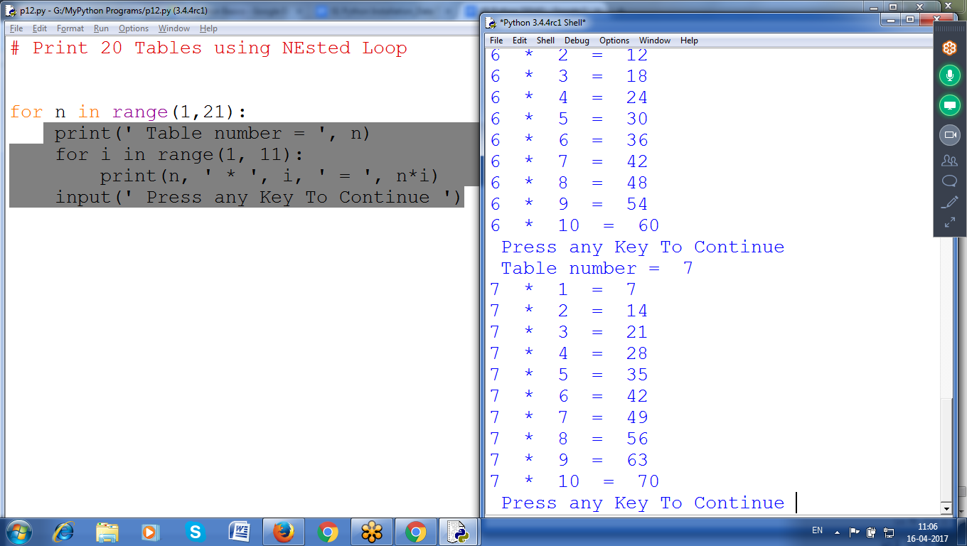

# Print 20 Tables using NEsted Loop

for n in range(1,21):

print(' Table number = ', n)

for i in range(1, 11):

print(n, ' * ', i, ' = ', n*i)

input(' Press any Key To Continue ')

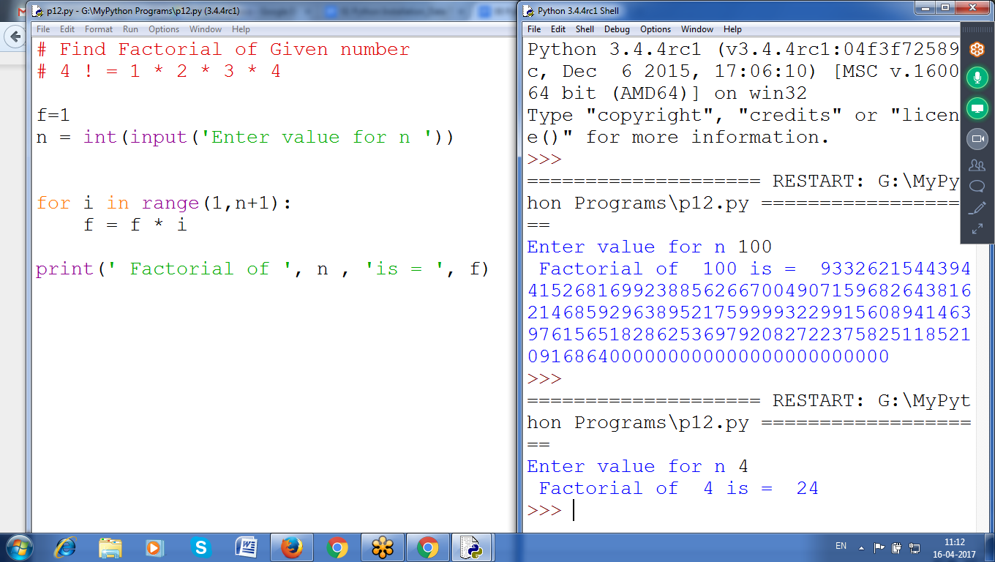

# Find Factorial of Given number

# 4 ! = 1 * 2 * 3 * 4

f=1

n = int(input('Enter value for n '))

for i in range(1,n+1):

f = f * i

print(' Factorial of ', n , 'is = ', f)

EASY to Learn

Move to any Environment (

Web: django

Data: Data Science, hadoop

REport : Tableau

Networking, security

**Python : Strings**

**Python : Regular Expressions**

**Python : Files**

**Python: Debugging, Exceptions**

**Python : Functions**

**Python : Collections (List, set , Dictionary)**

**python : OOPS**

**python : Generators and Decorators.**

**Web, GUI, Database, Data Structures**

**Gaming, Multithreading, Numpy, scipy**

**Jupyter, Pycharm (EDITORS)**

[**mybox1224@gmail.com**](mailto:mybox1224@gmail.com)

[**harshtechnologies24@gmail.com**](mailto:harshtechnologies24@gmail.com)

9.30 to 11.30 For 45 Days (60 Hours)

Monday or Wednesday

**Web Technology django** uses **PYTHON**

**Mobile Based Flask used Python**

**Data Science** Analytics uses **PYTHON**

**Big Data** **Hadoop** uses **PYTHON**

Amazon **Web Services** uses **PYTHON**

**Automation Tools** **Devops** uses **PYTHON**

**REporting Tools TABLEAU, Testing uses PYTHON**

**Deep learning, Machine Learning, AI**